Ideation Phase
Brainstorm and Idea
Prioritization
Date | 7 November 2025
Team ID | NM2025TMID09184
Project Name | Laptop Request Catalog Item
Maximum Marks | 4 Marks
Laptop Request Catalog Item Template:

This guided project demonstrates the creation of a Laptop Request Catalog Item in ServiceNow, enabling employees to efficiently request laptops through a dynamic and user-friendly form. The process involves creating a catalog item named “Laptop Request” under the Hardware category and adding variables such as Laptop Model, Justification, Additional Accessories, and Accessories Details to ensure accurate data collection. Dynamic behavior is configured using a Catalog UI Policy, which displays the Accessories Details field only when the Additional Accessories checkbox is selected, while a UI Action button labeled “Reset Form” allows users to clear all inputs easily. The project concludes with exporting the update set, importing it into another instance, previewing, and committing it to validate successful deployment. Overall, the solution streamlines IT asset requests, enhances consistency, improves workflow visibility, and elevates the user experience within ServiceNow.

Step-1: Team Gathering, Collaboration and Select the Problem Statement:

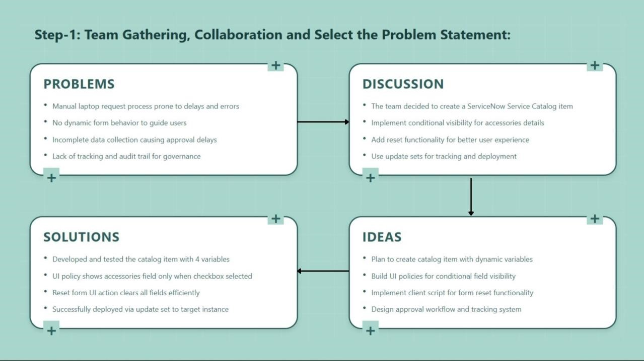
Step-2: Brainstorm, Idea Listing and Grouping:

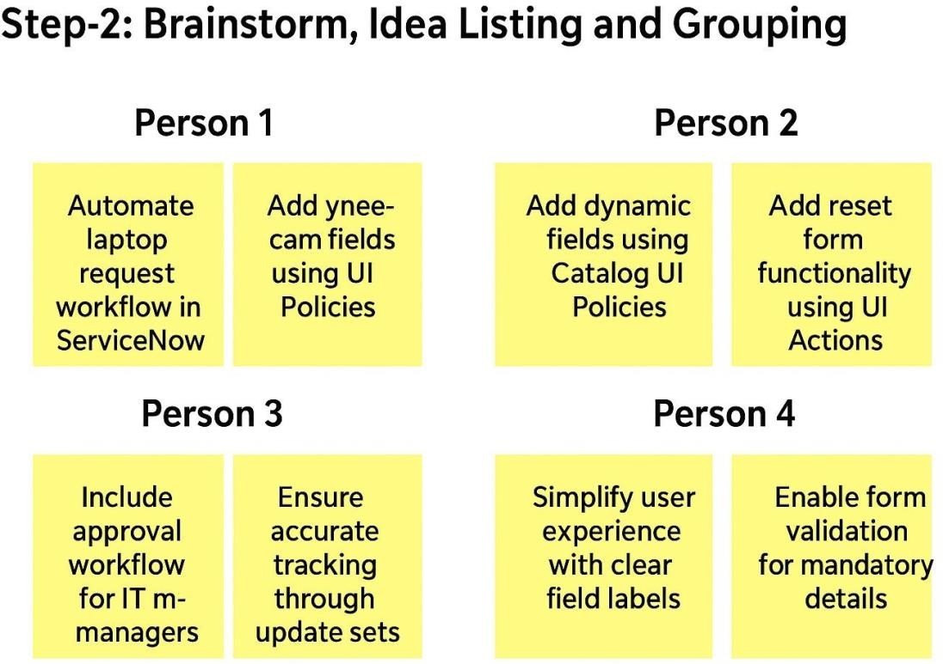

Brainstorm:
Team members discussed all possible ways to streamline the laptop request process using ServiceNow’s features like catalog items, UI policies, and update sets.
Idea Listing:
All ideas were noted, including:
- Use of catalog variables for structured input.
- Dynamic visibility for accessories details.
- Implementing reset functionality using client script.
- Exporting configuration using update sets for easy migration.
Grouping:
Ideas were grouped under key modules:
- Form Design (Catalog item, variables)
- Dynamic Logic (UI policy, visibility control)
- User Experience (Reset button, clear feedback)
- Deployment (Update set, migration, commit process) Action Planning:
Each module was assigned to team members to configure, test, and validate. Timelines were set to ensure smooth execution and integration.
Step-3: Idea Prioritization:

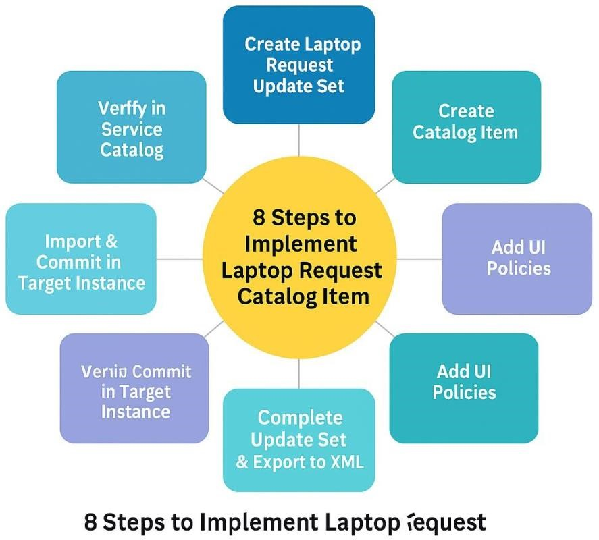

Idea Prioritization:
Prioritization focused on addressing critical business needs first—automating laptop requests and ensuring accurate data collection.
The team focused on:

- Creating a user-friendly form with clear variables.
- Implementing dynamic form behaviour for better guidance.
- Ensuring form reset capability for reusability.
- Maintaining deployment governance through update sets.

By organizing and prioritizing these ideas, the team successfully developed an efficient Laptop
Request Catalog Item that ensures accuracy, saves time, and improves overall IT service delivery. This structured approach enhances project clarity, supports quick adaptation, and aligns perfectly with ServiceNow’s ITSM best practices

